1-Network and Computer Network

1-Network

🌐 What Is a Network (In General)?
# Source: AI Source: Provided by: [Data Path: Persons Table -> ID Column: 1, Name_En Column: Motasem Essam] -> From: [ChatGPT] on [12/9/2025]
A network—in general—is a system of interconnected components that can communicate, share resources, or exchange information with each other.

🧠 In simple terms:
# Source: AI Source: Provided by: [Data Path: Persons Table -> ID Column: 1, Name_En Column: Motasem Essam] -> From: [ChatGPT] on [12/9/2025]
A network is a group of things connected together.

🔗 General Examples of Networks
# Source: AI Source: Provided by: [Data Path: Persons Table -> ID Column: 1, Name_En Column: Motasem Essam] -> From: [ChatGPT] on [12/9/2025]
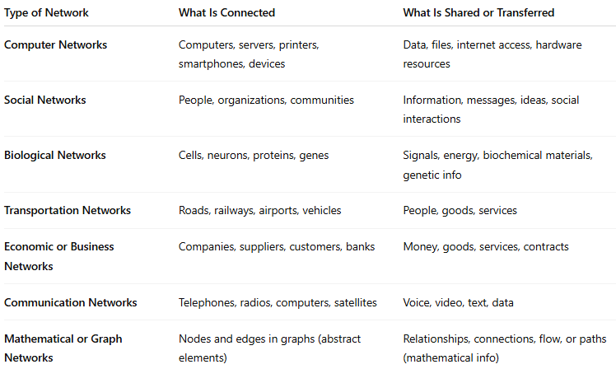
Type of Network | What Is Connected | What Is Shared or Transferred
Computer Networks | Computers, servers, printers, smartphones, devices | Data, files, internet access, hardware resources
Social Networks | People, organizations, communities | Information, messages, ideas, social interactions
Biological Networks | Cells, neurons, proteins, genes | Signals, energy, biochemical materials, genetic info
Transportation Networks | Roads, railways, airports, vehicles | People, goods, services
Economic or Business Networks | Companies, suppliers, customers, banks | Money, goods, services, contracts
Communication Networks | Telephones, radios, computers, satellites | Voice, video, text, data
Mathematical or Graph Networks | Nodes and edges in graphs (abstract elements) | Relationships, connections, flow, or paths (mathematical info)

1. Computer Networks
- Internet – the largest network connecting millions of devices worldwide.
- Local Area Network (LAN) – computers connected within a home, school, or office.
- Wireless Network (Wi-Fi) – devices connected through radio signals.

2. Social Networks
- Friendship network – people connected through personal relationships.
- Online social networks – platforms like Facebook, Instagram, or LinkedIn.
- Professional network – connections among colleagues and business partners.

3. Biological Networks
- Neural network – neurons connected in the brain to process information.
- Food web – predator–prey relationships in an ecosystem.
- Genetic networks – interactions between genes and proteins.

4. Transportation Networks
- Road networks – highways and streets connecting cities.
- Railway networks – train routes linking different regions.
- Airline route networks – airports connected by flight paths.

5. Economic or Business Networks
- Supply chain network – suppliers, manufacturers, distributors, and retailers.
- Trade networks – countries connected through imports and exports.
- Corporate networks – companies with shared interests or partnerships.

6. Communication Networks
- Telephone network – landline or mobile connections for voice communication.
- Broadcast networks – TV or radio stations distributing content.

7. Mathematical or Graph Networks
- Graph theory networks – nodes and edges representing relationships.
- Electric power grid – generators, transformers, and consumers connected by cables.

🔧 Key Characteristics of a Network
# Source: AI Source: Provided by: [Data Path: Persons Table -> ID Column: 1, Name_En Column: Motasem Essam] -> From: [ChatGPT] on [12/9/2025]
- Nodes (the individual points, like computers or people)
- Links (connections between the nodes, like cables or relationships)
- Communication or interaction (how information moves between nodes)

📝 Summary
# Source: AI Source: Provided by: [Data Path: Persons Table -> ID Column: 1, Name_En Column: Motasem Essam] -> From: [ChatGPT] on [12/9/2025]
A network is a system of connected elements that exchange or share something — whether in technology, biology, society, or infrastructure.

2-Computer Network

🌐 What Is a Computer Network?
# Source: AI Source: Provided by: [Data Path: Persons Table -> ID Column: 1, Name_En Column: Motasem Essam] -> From: [ChatGPT] on [12/9/2025]
A computer network is a system where two or more computers or devices are connected to share resources, exchange data, and communicate with each other. Networks can range from small setups in a home to vast global systems like the Internet.

🧠 In Simple Terms:
# Source: AI Source: Provided by: [Data Path: Persons Table -> ID Column: 1, Name_En Column: Motasem Essam] -> From: [ChatGPT] on [12/9/2025]
Network = Devices linked together to share data and resources.
These connections can be wired (Ethernet cables) or wireless (Wi-Fi, Bluetooth).

✅ Common Types of Networks:
# Source: AI Source: Provided by: [Data Path: Persons Table -> ID Column: 1, Name_En Column: Motasem Essam] -> From: [ChatGPT] on [12/9/2025]
- LAN (Local Area Network): Covers a small area like a home, office, or school.
- WAN (Wide Area Network): Covers large areas, cities, or countries; the Internet is the largest WAN.
- MAN (Metropolitan Area Network): Spans a city or large campus.
- PAN (Personal Area Network): Connects personal devices like smartphones, tablets, and laptops.
- CAN (Campus Area Network): Links multiple LANs within a campus or business area.

🔧 What a Network Can Do:
# Source: AI Source: Provided by: [Data Path: Persons Table -> ID Column: 1, Name_En Column: Motasem Essam] -> From: [ChatGPT] on [12/9/2025]
- Share files and data easily between devices.
- Share hardware like printers and scanners.
- Access the internet collectively.
- Enable communication through emails, chats, or video calls.
- Support online gaming and streaming services.

✅ Key Purposes of Computer Networks:
# Source: AI Source: Provided by: [Data Path: Persons Table -> ID Column: 1, Name_En Column: Motasem Essam] -> From: [ChatGPT] on [12/9/2025]
- Resource Sharing: Reduce costs by sharing printers, storage, and software.
- Communication: Facilitate emails, messaging, and conferencing.
- Data Access: Allow multiple users to access the same data or applications.
- Centralized Management: Easier monitoring and management of devices.

📶 How It Works:
# Source: AI Source: Provided by: [Data Path: Persons Table -> ID Column: 1, Name_En Column: Motasem Essam] -> From: [ChatGPT] on [12/9/2025]
- Devices connect through physical cables (Ethernet) or wireless signals (Wi-Fi).
- Data is broken into small packets, sent over the network, and reassembled at the destination.
- Network devices like routers and switches direct the data to the right location.

🔧 Basic Components:
# Source: AI Source: Provided by: [Data Path: Persons Table -> ID Column: 1, Name_En Column: Motasem Essam] -> From: [ChatGPT] on [12/9/2025]
- Computers/Devices: Endpoints like PCs, laptops, smartphones.
- Network Interface Cards (NICs): Allow devices to connect to the network.
- Cables/Wireless Media: Physical wires (Ethernet) or Wi-Fi signals.
- Switches & Hubs: Connect multiple devices within a network.
- Routers: Connect networks and manage data traffic.
- Servers: Provide resources like files, emails, or web services.

Summary:
# Source: AI Source: Provided by: [Data Path: Persons Table -> ID Column: 1, Name_En Column: Motasem Essam] -> From: [ChatGPT] on [12/9/2025]
A computer network links multiple devices to share resources, communicate, and access the internet. Networks can be small or global and use various devices and technologies to send data efficiently. They are essential for modern communication, business, education, and entertainment.

